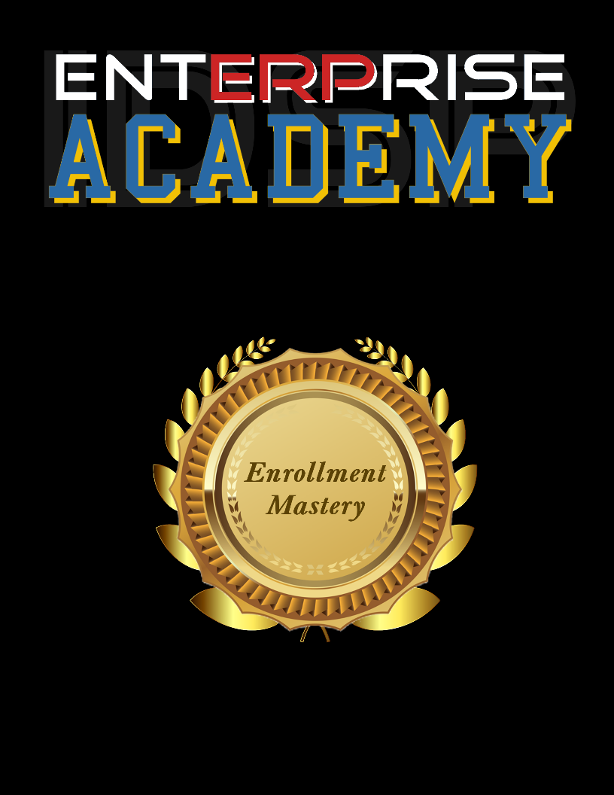Orientation

Module 1 – CONNECTION

**Finding Your Common Ground**

|  |
| --- |
| How is your day going? |
| Where did you just come from? |
| What were you doing before you got here? |
| Have you eaten here before? Can you recommend something? |
| How is this weather treating you? |
| Do you have kids? How many? |
| This weather’s great for __________. I love to __________. Do you have any hobbies? |
|  |
|  |
|  |

Module 2 – PURPOSEFULNESS

**The Reason for the Meeting**

|  |
| --- |
| I want to honor your time and mine. I it alright if I ask you a little bit about your___________  (ask questions relative to your field of expertise.) |
| What is the nature of your work? How do you help people? |
| What kind of clientèle do you serve? |
| How many clients do you serve per month? |
|  |
|  |
|  |
|  |
|  |
|  |

Module 3 – VALIDATION

**Letting Them Know They Matter**

|  |
| --- |
| What do you love about doing what you do? |
| What’s your favourite kind of client? |
| Tell me about the best client you ever had? |
| What’s the best testimonial you’ve ever gotten? |
| What you do is such a great value to the world. I would love to support you. Can you tell me a little bit more about what you do? |
|  |
|  |
|  |
|  |
|  |

Module 4 – DISCOVERY

**Matching Their Needs to Your Service**

|  |
| --- |
| How is your ________________ doing? (health, business, lifestyle, relationship) |
| What difficulties are you having? |
| How is this negatively affecting your____________? (health, business, lifestyle, relationship) |
| What do you think may be causing this or sabotaging your success? |
| If you could wave a realistic magic wand and you could have your ____________ anyway you wanted, what would your _____________ be like? |
| If everything was working out perfect, what would your life be like? (health, business, lifestyle, relationship) |
| What would you do with your time? |
| And what would that be like? |
| Where would you go? |
| What would you do? |

Module 5 – IMPLICATION

**What’s going to happen if they don’t fix the problem?**

|  |
| --- |
| How long have you been putting up with this? |
| How is this affecting your ___________? (health, business, lifestyle, relationship) |
| It seems like there’s a pattern here. How much do you think this has cost you since it began? |
| How much do you think it’s going to cost you over the next year, if you don’t break this pattern? |
| Over 3 years? |
| Over 5? |
| Is this something that you want to keep putting off? |
| How much longer can you live with this? |
| On a scale of 1 to 10, how serious are you about solving this. (1-not at all. 10-at any cost.) |
|  |
|  |

Module 6 – OPPORTUNITY

**Giving Your Candidate a Chance to Grow**

|  |
| --- |
| Of our time here together, what have you found most valuable? |
| If I could show you a way to eliminate _________ from your life, (read notes back to them) so you can___________(read notes back to them) and do ______________(read notes back to them) then would you like to hear about that? |
| Well, it just so happens that I have a program designed especially for people like you...(tell them about your program.) |
| As you reveal each stage of your program, be sure to establish value by asking what that would be worth to them before moving on to telling them about the next stage. |
| Be sure to ask them if they want to hire you before telling them the price. |
| Once you are familiar with objections or concerns, use bonuses to overcome them and be sure to reveal bonuses *after* you tell them the price. |
|  |
|  |
|  |
|  |

Module 7 – CAMPAIGN STRATEGIES

**Scheduling Meetings and Getting Hired**

|  |
| --- |
| ? |
| ? |
| ? |
|  |
|  |
|  |
|  |
|  |
|  |
|  |